Understanding Document

For

Digital Barrier Analysis Tool

Contents

Authentication: 2

Pages: 2

1. LR Client login 2

2. DBA Project Selection 2

3. DBA Manage Accounts 2

4. DBA Home 2

5. DBA Setting 2

6. Workshop 3

7. Create/Update Record 3

8. DBA Results 3

9. Summary 3

Data Modeling 4

# 

# Authentication:

For now, the preferred method of authentication is via AWS Cognito and we will doing our development on that basis for now.

**Queries & issues:**

* As we will be basing our authentication method on the basis of AWS Cognito, in future if the authentication method is changed to something else then there will be code rewrite required in the system.
* As discussed in kick off meeting, we have setup AWS Congnito and also imported the users into the user pool. But we are not sure what the user attributes should be in user pool and how LR trying to implement it in future. This may cause the integration issues with our application in future. On top of that when we create users in AWS Cognito all the user’s email needs to be verified which requires additional functions to be prepared in our end which was not initially in our scope of work. So, to save the time and confusion it would be better if we could get a pre-setup AWS Cognito with preloaded user pool for us to work with.

# Pages:

## LR Client login

The client will be able to login to the tool using this page. The details regarding authentication is discussed above.

## DBA Project Selection

This is the landing page where the users will be landed to after the login. The user will be able to see the projects assigned to them in this page. The project listed will have basic information like Project Name, Project ID, Country and Site. Clicking the project will navigate the user to the project page. In case of Admin user, they will be able to see “Create New Project” button. Click that will open a modal with the form to create a new project.

## DBA Manage Accounts

Only the Organization Admin & Project admin will have access to this page. This page will be used to assign user roles to the users on a per project basis. Organization admin will be able to assign the users to any projects. In case of Project Admin, they will only be allowed to assign the users to the project they are admin in.

## DBA Home

This is the landing page for the project. The user will be sent to this page from Project selection page.

## DBA Setting

This page is only accessible to the Project Admin and is used to set the parameters for the project. The admin will be able to update the following parameters

1. Work Type
2. Work Operation
3. Potential Incident
4. Risk Matrix

Note: Work Type, Work Operation and Potential Incident has hierarchical relation.

## Workshop

This page is accessible to “In-house personnel” user. The user here will be able to see the list of record present in the system. The user will also be able to import new records to the system. There are two risk matrices in the screen showing the number of records in each risk zone. Clicking the box will filter the main table with the values being clicked.

**Queries & issues:**

* We require the format of the excel being imported to the system.
* What file format should we support for import? CSV or XlSX?

## Create/Update Record

This1 page is accessible to “In-house personnel” user. The user can create/update the records in the system by filling the forms.

**Queries & issues:**

* We had received “Standard BA workshop template[4].xlsx” explaining us the Barrier Analysis being done in the system. But the wireframe and RD provided to us is missing many of the attributes listed in the excel. Are the attributes found in the excel correct? Please have a look into “Data Modeling” section to verify the attributes.
* We also require information on where the additional attributes should go in the page in wireframe.

## DBA Results

“Field Personnel” will have access to this. The user will be able to check the incidents in the page by entering Work Type and Work Operation from the dropdown. A risk matrix will also be displayed on the right side of the page with the values being populated as per the choices being made in drop down. The user will also be able to export the records in the format defined in wireframe.

**Queries & issues:**

* Requirement 102 & 103 of the page is in Medium priority but comment says: “LR: To be included in pilot development UX/UI”. What does this mean? Will this be included in pilot phase.

## Summary

This page will display the summary of all the records present in the system. The user can select “Work Type” & “Work Operation” and it will show the charts of the records with relevant information as defined in wireframe. The user will also be able to export this chart. The user will also be able to see the Recommendation List in the page and also see the count of Records, Recommendations & Critical issues present in the system.

**Queries & issues:**

* Requirement 112, 113, 114, 115, 122 & 124 of the page is in Medium priority but comment says: “LR: To be included in pilot development UX/UI”. What does this mean? Will this be included in pilot phase.
* Where is the recommendation list coming from?
* Where is the count for Critical issue coming from?

# Data Modeling

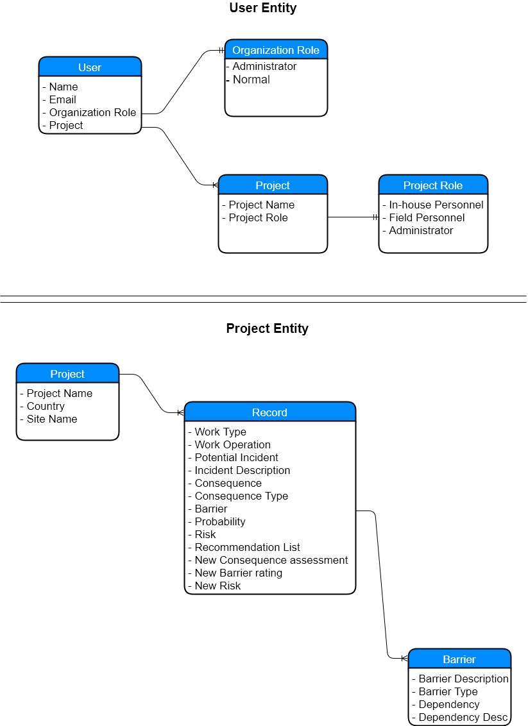

We have prepared the above data modelling on the basis of RD and wireframe available to us.